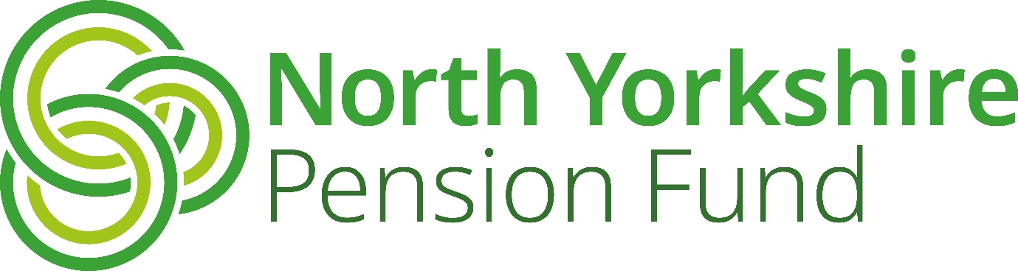

Fund

Retirement Planning Guide

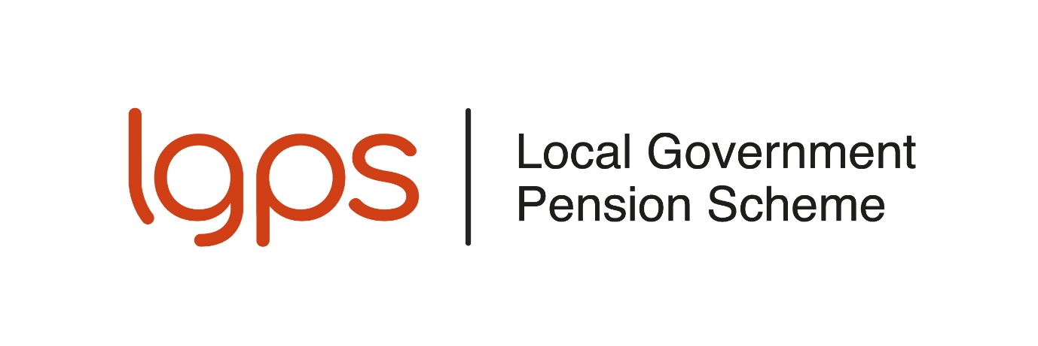

If you require this information in an alternative language or another format such as large type, audio cassette or Braille, please contact the Pensions Help & Information Line on 01609 536335

Introduction 3
Part 1 – The L G P S 3
Benefits of the Scheme 3
How your LGPS benefits are worked out 5
When you can take your pension 8
Taking a tax-free lump sum when you retire 10
After you have taken your pension 14
Taking your L G P S pension – the process 15
Help if you have a query or complaint 18
Part 2 – Other useful information 19
State Pension 19
Tax and your pension 19
Tracing previous pension rights 20
Pension scams 20
If you suspect a scam, report it. 21
Where to go for support 21
Budget Planner 23
How to find out more 24
Disclaimer 24
Notes 25

Introduction

This guide is for you if you are currently paying into the Local Government Pension Scheme (L G P S) and are planning your retirement.
Part one of this guide gives you information about the L G P S. It covers the financial protection the L G P S offers you and your family. Part one also includes information about retirement and the decisions you have to make.
Part two looks more widely at issues that may affect you in retirement. We have included information about taxation and the State Pension. You can also find links and contact details for organisations that can support you.
The purpose of this guide is to assist you with retirement planning. You should not use it instead of financial advice. If you require financial advice, you should appoint an independent financial advisor.

Part 1 – The LGPS

Benefits of the Scheme

A secure pension
Your pension is worked out each Scheme year and is based on your pensionable pay. The Scheme year ends on 31 March. In the April following the end of each year, your pension is adjusted in line with changes in the cost of living. You can read more about how your pension is worked out in the next section, How your L G P S benefits are worked out.


Survivor pensions
After your death, a pension will be paid to your:
- spouse
- civil partner or
- cohabiting partner (subject to qualifying conditions)
for the rest of their life. Children’s pensions may also be payable.

Taking a lump sum

When you take your pension, you have the option to swap some of it for a tax-free lump sum. The lump sum will be paid tax-free in most cases. However, there is a limit on how much tax-free cash you can take from your pension. If you exceed that limit, you will have to pay tax at your marginal rate.

Tax relief
Pension contributions are taken from your salary before tax is worked out. If you pay tax, as a member of the Scheme you will pay less tax on your earnings.

Flexibility to pay more or less
You can pay half your normal contributions in return for building up half of your normal pension. This is known as the 50/50 section of the Scheme.
You can increase your pension by paying more contributions. You can read more about this in the Increasing your pension section of this guide.

Life cover
If you die as an active member of the L G P S, a death grant of three times your assumed pensionable pay is payable. Assumed pensionable pay is an estimate of your normal annual pensionable pay. The North Yorkshire Pension Fund (NYPF) will decide who to pay any death grant to but will take account of your wishes. You can update your details on your online pension record at www.nypf.org.uk > My Pension Online. Alternatively, you can print a Lump Sum Death Grant Nomination form from the NYPF website at www.nypf.org.uk > Forms/Guides > Forms.

Further information
You can find out more about the benefits of L G P S membership on the L G P S member website. You can also watch the Pensions made simple videos.

How your LGPS benefits are worked out
The L G P S changed from a final salary scheme to a career average scheme on 1 April 2014. From 1 April 2014, the benefits built are worked out under the rules of the career average scheme.
If you joined the Scheme before 1 April 2014, you have also built up benefits in the final salary scheme.

How your benefits are worked out after 31 March 2014
Each year, 1/49th of your pensionable pay is put into your pension account. Your pension is protected if your pay is lower than usual because of sickness or child-related absence.
In the April following the end of each year, your pension account is adjusted in line the cost of living. The table in the example below shows how this works.

How your benefits are worked out between 1 April 2008 and 31 March 2014
For each year of membership between 1 April 2008 and 31 March 2014, you will receive a pension of 1/60th of your final pay.
Your final pay is usually the pensionable pay you earn in the year before leaving the Scheme. Pay from one of the two previous is used instead if it is higher.

How your benefits are worked out before 1 April 2008
For each year of membership before 1 April 2008, you will receive a pension of 1/80th of your final pay, and a lump sum of 3/80ths of your final pay.

Working part-time
If you worked part-time before 1 April 2014, your membership is reduced accordingly. For example, if you worked 18.50 hours per week and the full time hours for the job were 37 hours per week, your membership will be reduced by 18.50/37.00, which is half. We use your full-time equivalent pay to work out your benefits.
The following example shows how L G P S benefits are calculated for a member:
- retiring at normal pension age on 31 March 2026
- with 30 years of L G P S membership
- whose final pay is £43,000
- who has built up a pension account since 1 April 2014 as shown in the table.

Example 1 – calculation of L G P S benefits
Benefits based on six years’ membership from 1 April 2008 to 31 March 2014:
Pension: 6 ÷ 60th x £43,000 = 4,300

Benefits based on 12 years’ membership up to 31 March 2008:
Pension: 12 ÷ 80th x £43,000 = £6,450
Lump sum: 3 x 12÷ 80th x £43,000 = £19,350

Table 1: Benefits built up in the career average scheme from 1 April 2014

Scheme year | Opening balance | Pension built up in Scheme year | Total account 31 March | Cost of living adjustment (CPI) | Updated total account
2014/15 | £0. | £27,600 ÷ 49  = £563 | £563 | £7 (1.2%) | £570
2015/16 | £570 | £28,100 ÷ 49  = £573 | £1,143 | -£1 (-0.1%) | £1,142
2016/17 | £1,142 | £29,900 ÷ 49  = £610 | £1,752 | £18 (1.0%) | £1,770
2017/18 | £1,770 | £30,600 ÷ 49  = £624 | £2,394 | £72 (3.0%) | £2,466
2018/19 | £2,466 | £30,900 ÷ 49  = £631 | £3,097 | £74 (2.4%) | £3,171
2019/20 | £3,171 | £32,700 ÷ 49 = £667 | £3,838 | £65 (1.7%) | £3,903
2020/21 | £3,903 | £33,400 ÷ 49 =£682 | £4,585 | £23 (0.5%) | £4,608
2021/22 | £4,680 | £34,800 ÷ 49 = £710 | £5,318 | £165 (3.1%) | £5,483
2022/23 | £5,483 | £35,800 ÷ 49 = £731 | £6,214 | £621 (10.1%) | £6,835
2023/24 | £6,835 | £39,400 ÷ 49 = £804 | £7,639 | £512 (6.7%) | £8,150
2024/25 | £8,150 | £42,150 ÷ 49 = £860 | £9,010 | £153 (1.7%) | £9,163
2025/26 | £9,163 | £43,000 ÷ 49 = £878 | £10,041 | £201 (2.0% *) | £10,242

*Assumed figure

The member is entitled to:
Annual Pension £20,992

Which is made up of pension built up:

before 1 April 2008 £6,450
between 1 April 2008 and 31 March 2014 £4,300
after 31 March 2014 £10,242
Tax free lump sum £19,350

Underpin protection
When the LGPS changed from a final salary scheme to a career average scheme in 2014, older members were protected from the changes. The courts have found that younger members of other public service pension schemes were discriminated against because similar protections did not apply to them.
The LGPS rules changed in 2023 to remove this discrimination. These changes are known as the ‘McCloud remedy’. Your LGPS pension may be protected by the underpin if you:
- joined the LGPS or a different public service pension scheme before 1 April 2012
- reach age 65 after 1 April 2014
- were a member of the LGPS between 1 April 2014 and 31 March 2022, and
- have not had a disqualifying break. A disqualifying break is a break of more than five years when you were not paying into the LGPS nor any other public service pension scheme.
You do not need to make a claim for underpin protection. However, the NYPF may need to ask you about previous membership of the LGPS or a different public service pension scheme to find out if you are protected.
If you are protected, when you retire, the NYPF will check whether the pension you built up in the underpin period would have been more under the final salary scheme. If it would have been, your pension will be increased. The underpin period runs from 1 April 2014 to 31 March 2022. Your protection ended earlier if you reached age 65 before 31 March 2022

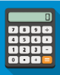
Further information
For more information about how your L G P S pension is worked out and to use an online modeller, please visit the L G P S member website. For more information about underpin protection, see the McCloud remedy section of the website.

When you can take your pension
You can choose to stop work and take your pension at any time between age 55 and 75. Your normal pension age (NPA) is the age when you can retire and take the pension you have built up without early retirement reductions.

For the pension built up from 1 April 2014, your NPA is the same as your State Pension age (SPA), but with a minimum age of 65. You can find out your SPA by using the Government's State Pension Age calculator.
Any benefits you built up before 1 April 2014 have an NPA of 65. You must take your whole L G P S pension at the same time.

Taking your pension before your NPA
There is no reduction if you take your pension at your NPA. If you take your pension before your NPA, it will be reduced. The reduction is based on the number of years and days from the date you take your pension to your NPA.

Early retirement reduction factors
The Government sets the early retirement reduction factors. They can vary from time to time. The table below shows the reduction factors that are currently in force:
Table 2: Early retirement reduction factors
Number of years  paid early | Pension reduction | Lump sum reduction (for membership to 31 March 2008)
0 | 0% | 0%
1 | 4.9% | 1.7%
2 | 9.3% | 3.3%
3 | 13.5% | 4.9%
4 | 17.4% | 6.5%
5 | 20.9% | 8.1%
6 | 24.3% | 9.6%
7 | 27.4% | 11.1%
8 | 30.3% | 12.6%
9 | 33.0% | 14.1%
10 | 35.6% | 15.5%
11 | 49.5% | n/a
12 | 41.8% | n/a
13 | 43.9% | n/a

If you were a member of the L G P S on 30 September 2006, some or all of your benefits paid early could be protected from the reduction under the ‘85-year rule’. You can read more about Taking your LGPS pension and the 85 year rule on the LGPS member website.

Taking your benefits after your NPA
If you stay in work after your NPA, you will continue to pay into the L G P S and build up further benefits. You must take your pension by age 75.
If you delay taking your pension, your benefits will be increased. The increase is based on how long after your NPA you take your pension.

Ill health
If you have to leave work due to illness, you may be able to receive your L G P S pension straight away. Your employer must be satisfied that you are permanently unable to do your job until your NPA and that you are not immediately capable of gainful employment. They must get an opinion from an independent occupational health physician before they decide.
Ill health benefits can be paid at any age and are not reduced because of early payment. In fact, your benefits could be increased to make up for your early retirement.
Redundancy and business efficiency
The L G P S benefits you have built up will be paid immediately without any early retirement reductions if:
- you are age 55 or over
- you have been a Scheme member for at least two years, and
- your employer makes you redundant or you are retired on the grounds of business efficiency.


Flexible retirement
From age 55, if you reduce your hours or move to a less senior position, and your employer agrees, you can take some or all of the pension benefits you have built up.
You can draw your wages from your reduced hours or less senior post and continue paying into the L G P S, building up further benefits in the Scheme.

Pension age changes
The Government has announced that the earliest age you can take your pension will increase from 55 to 57 from 6 April 2028. This does not apply if you have to take your pension early due to ill health.
Pension Scheme rules allow the Government to protect members who joined the LGPS before 4 November 2021 from these changes. The Government has not yet confirmed if it will allow members who joined the Scheme before 4 November 2021 to take their LGPS benefits before age 57 from April 2028.

Cost of living adjustment

Your LGPS pension increases in line with the cost of living every year throughout your retirement. If the cost of living goes up, so does your pension. Further information

Further information
You can read more about Taking your LGPS pension. You can also watch the Pensions made simple videos ‘Life after work’ and ‘Protection for you and your family’.

Taking a tax-free lump sum when you retire
When you take your pension, you can choose to swap some of it for a lump sum. For every £1 of annual pension you give up you will receive a lump sum of £12.
If you joined the L G P S before 1 April 2008 you will receive a tax-free lump sum when you take your pension. You will also have the option to swap some of your pension to increase your lump sum.
Most members can take up to 25% of the overall value of their pension as a lump sum. The lump sum will usually be tax-free. HMRC limits the total amount of tax-free cash you can take from all UK pension schemes. The limit is £268,275. A higher limit may apply if you hold protection from the lifetime allowance. If you exceed the limit, you will have to pay tax on the excess at your marginal tax rate.

Example 2: swapping pension for lump sum
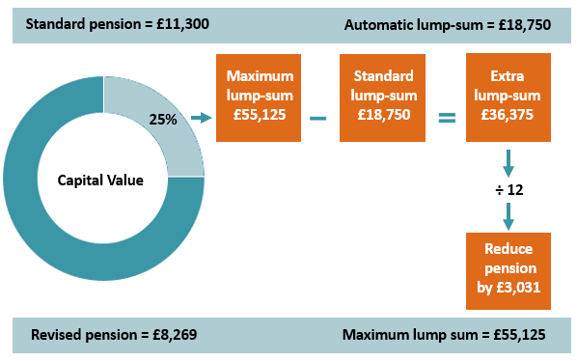
When Liz retires, she has a standard annual pension of £11,300 and an automatic tax-free lump sum of £18,750. Liz can take up to 25% of the capital value as a tax-free lump sum, which is £55,125. If she does, she will receive an extra £36,375 lump sum and her annual pension will reduce by £3,031 to £8,269.
Taking a larger lump sum reduces your pension but does not reduce any survivor pension paid after you die to your spouse, civil partner, eligible cohabiting partner or child.
It is very important that you think carefully about this option before you take your pension. It will not be possible to reverse your decision after your pension has been paid. The NYPF will give you more information about this option when you take your pension. Please see Taking your L G P S pension - the process for more details.
The NYPF will ask you for details of any tax-free lump sums you have already received when you take your pension.

Recycling
Using your tax-free lump sum to increase the contributions you pay to a pension scheme, this is known as ‘recycling’. This is a complex area and HMRC will only consider that recycling has occurred if all the relevant conditions are met. If HMRC considers that recycling has occurred, then you will have to pay extra tax.
You can find out more about lump sum recycling from HMRC. You may wish to seek regulated financial advice if you think recycling might apply to you.

Further information
You can find out more information and use a lump sum calculator on the L G P S member website.


Increasing your pension
The budget planner at the end of this guide will help you work out what income you will need when you stop working. In this section, we look at ways you could increase that income.
You can pay extra contributions to increase your pension by paying:
- additional pension contributions (APCs)
- in-house additional voluntary contributions (AVCs)
- free-standing AVCs
- into a personal or stakeholder pension

Additional pension contributions (APCs)
If you are in the main section of the Scheme, you can pay extra contributions to buy up to £8,903 of annual pension. Any extra pension you buy is added to your L G P S pension. You can pay for this extra pension by regular contributions from your pay or by paying a lump sum.

In-house additional voluntary contributions
Additional voluntary contributions (AVCs) allow you to pay more to build up extra savings for your retirement. In-house AVCs are invested separately in funds managed by the Pension fund’s in-house AVC provider, Prudential. You would benefit from tax relief on the AVC contributions that you pay.
Your employer may offer a shared cost AVC through a salary sacrifice arrangement. If they do, both you and your employer would pay less national insurance. Check with your employer if they offer a salary sacrifice scheme for AVC contributions.
When you take your L G P S pension, you can use your AVC fund to buy a guaranteed income for life (an annuity) or buy a top-up L G P S pension. Subject to HMRC limits, you may be able to take up to 100% of your AVC fund as a tax-free lump sum. You can transfer your AVC fund to another pension scheme or arrangement at any time before you take your L G P S pension.
For more information please visit the NYPF website at www.nypf.org.uk > Members > All Members > Active Members > Increasing your Benefits


Freestanding additional voluntary contributions (FSAVCs)
These are similar to in-house AVCs but they are not linked to the L G P S in any way. With FSAVCs, you choose a provider, usually an insurance company. You may want to consider their different charges, alternative investments and past performance.

Personal or stakeholder pensions
You can pay into a personal pension plan or stakeholder pension scheme at the same time as paying into the L G P S. You need to consider charges, alternative investments and past performance when you choose a provider.
Important: It is advisable to get financial advice before taking out any form of additional pension savings.

Further information
You can find more information on paying more to increase your pension on the L G P S member website. You can also watch the Pensions made simple videos, including ‘Managing your pension’.

Tax and your pension
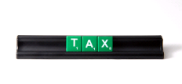
One of the benefits of pension saving with the L G P S is that you receive tax relief on the contributions you pay. HM Revenue and Customs (HMRC) restricts the amount of tax relief you can receive. Most people will be able to save as much as they wish because their pension savings will be less than the limits.
If you are thinking of paying extra, you should be aware of these limits. There is no limit on the amount of contributions you can pay. You will only get tax relief on contributions up to 100% of your taxable earnings in a tax year.

Annual allowance
The annual allowance is a limit on how much your pension benefits may increase in a tax year without you having to pay a tax charge.
In the L G P S, the amount of annual allowance used is the growth in the value of your pension benefits over the tax year.
For money purchase arrangements, such as AVC schemes, the annual allowance you use is the total contributions paid by you, and on your behalf, over the tax year.
The NYPF will inform you if your L G P S pension savings exceed the standard annual allowance by sending you a pension saving statement. The statement must be sent to you by 6 October following the end of the tax year.
Important: you may be paying into more than one pension scheme. It is your responsibility to check that your total pension savings across all schemes do not exceed the annual allowance limit.

Further information You can find more information on the annual allowance, including a tool to check your position, on the L G P S member website. You can also watch the Pensions made simple video, ‘Your annual allowance’.

After you have taken your pension
In this section, we look at events that may happen once you are taking your L G P S pension.


You get a new job
If you get a new job in local government, or with an employer who offers membership of the L G P S, you must tell the NYPF in writing. Your pension is not usually affected.

If you are receiving a tier three ill health pension, you must let your former employer know if you start any paid work.

If you return to work, your tax code may change. HMRC can answer general queries about tax codes. details.

You move abroad
Your L G P S pension can generally be paid to an overseas bank account. If you are thinking of moving abroad, please contact the NYPF to ensure your pension payments continue.


Your marital status changes
You need to keep the NYPF informed of any change in your marital status by forwarding a copy of the certificate. This ensures that in the event of your death we have up to date details.
You may also wish to update your death grant nomination form to let the NYPF know who you would like any death grant paid to. The quickest way to do this in on your online pension record at www.nypf.org.uk > My Pension Online. Alternatively, you can download a form at www.nypf.org.uk >Forms/Guides > Forms.

You change address
If you move house or change bank account, you must tell the NYPF. You can update your address on your online pension record at www.nypf.org.uk > My Pension Online. Alternatively, you can email us at pensions@northyorks.gov.uk or telephone 01609 536335.

Death benefits

Once you take your pension, it is paid to you for the rest of your life.
If you die after you have taken your pension, payment of your pension will stop. Your next-of-kin or the person dealing with your estate should inform the NYPF of your death. They should do this as soon as possible so your pension is not overpaid.
If you die before age 75 and less than ten years’ pension has been paid to you, a grant may be paid. The amount payable would be:
- ten times your annual pension (adjusted if you swapped pension for tax-free lump sum)
- less the amount of pension already paid to you.
A survivor pension will be paid to your spouse or civil partner after you die. A survivor pension may be paid to your cohabiting partner and/or children, subject to certain qualifying conditions.

Further information
You can find out more about death benefits in the L G P S on the L G P S member website. You can also watch the Pensions made simple videos, including ‘Protection for your family’.

Taking your LGPS pension – the process
In this section we look at:
- what you should think about when you are planning to take your L G P S pension, and
- what happens next when you have made a final decision to take your pension.

Pre-retirement training
Some employers offer courses for their employees who are approaching retirement. Topics covered will vary depending on who is delivering the course. Attending this type of session can give you:
- useful information about what you should consider before retirement
- the opportunity to have an expert answer your questions
- a forum to share your views and experiences with colleagues who are also approaching retirement.
Contact your employer to find out what training they offer.

Notice period
The process to pay your L G P S pension can be complex. You may need to give your employer more notice than the period set out in your contract of employment to make sure your pension is paid on time.

Income and spending after retirement
It is important that you think about your retirement income before you leave your job. Some costs will reduce after you stop working. Your travel costs may drop, you are likely to pay less tax and you will not pay national insurance. Other costs such as household bills may increase when you stop working.
Depending on your age when you stop working, you may be able to take your State Pension. You can find more information about the State Pension in Part two of this guide. We have provided a basic budget planner at the end of this guide to help you.

Pension Wise guidance
Pension Wise is a government service from MoneyHelper. It offers free, impartial guidance to members aged 50 and over on what they can do with their defined contribution savings, such as AVCs.
You must either attend a guidance appointment with Pension Wise or opt out of attending one before you can start receiving your AVCs. We encourage you to attend the appointment as it may help you understand your AVC options. If you wish, we can book the appointment on your behalf. We will give you more information when we contact you about taking your LGPS pension and AVC.

Your LGPS pension
Your annual benefit statement shows the L G P S benefits you have built up to 31 March each year and an estimate of the benefits you would receive if you remained in employment until your normal pension age (NPA).
It is important that you know how much your pension benefits will be on your chosen retirement date before you make a final decision. The figures in your statement may not tell you:
- the reduced benefits that would be paid if you retire early
- the benefits that would be paid if your pay or working hours have changed recently or will change before you take your pension
- the effect of a pension sharing order (if part of your pension has been awarded to your former partner following a divorce or dissolution of a civil partnership)
- what your options are if you have an in-house AVC
- if you will be affected by HMRC limits on pension savings.
You can also run your own pension estimates (as often as you like) on your online pension record at www.nypf.org.uk > My Pension Online. Alternatively, you can email your request to pensions@northyorks.gov.uk.

Please note that if you are paying AVCs, would like a transfer value for divorce purposes or you require an annual allowance or lifetime allowance figure you will need to contact the NYPF as these calculations are not available on your online pension record.
Your employer will need to request a pension estimate on your behalf if you:
- are considering flexible retirement
- may be leaving due to redundancy or business efficiency over age 55
- may have to leave your job because of ill health.
The summary below shows a basic outline of the process that will be followed once you have made a final decision to take your L G P S pension.
Step 1 Talk to your employer and agree your retirement date
Step 2 Your employer gives the NYPF information about your pay, leaving date and reason for leaving
Step 3 The NYPF calculate(s) an estimate of your pension benefits which is sent to you with forms for you to confirm:
- that you wish to take your pension (if applicable)
and, if you are taking your pension:
- your option to swap pension for lump sum
- information about pensions and lump sums that have already been paid to you
- AVC payment options, if you have an in-house AVC and confirmation that you have attended a Pension Wise guidance appointment or opted out of attending one.
You will also be asked for bank details and a copy of your birth certificate or passport
Step 4 You return the pension claim forms and any certificates that the NYPF have requested.
Remember - once you have made a decision on:
- whether to swap pension for lump sum and
- how you want your in-house AVC to be paid
these decisions are final and cannot be reversed later
Step 5 The NYPF arranges payment of your pension and any lump sum after your retirement date.

Additional Information
The NYPF can only calculate your pension benefits (Step 3) after your employer has provided all the information needed. Once the information has been received, the NYPF aim to provide you with a pension calculation within 10 working days.
The NYPF will tell you when your benefits will be paid. Lump sum payments (if applicable) are made every Friday and payment will be made on the first available Friday following receipt of all the relevant paperwork. This can be up to four to six weeks from the date you retire. Pension payments are made by BACs into your chosen bank account on the last working day of each month and are processed by North Yorkshire Council’s Payroll Services. Due to payroll deadlines, it is likely that your first pension payment may be paid up to two months after you have retired but payments will be backdated.
Please be aware that payment of your pension benefits may take longer if you have an in-house AVC fund or you are affected by the annual. You should consider these timings when deciding how much notice to give.
The NYPF will send details of your pension payments to HMRC. HMRC will provide a revised tax code, if needed. You can read more about tax in Part two of this guide.

Getting further help
The decisions you make when you take your pension will affect your income in later life. It is important that you make the right decisions. Many organisations provide support, guidance and information. You can find contact information for support organisations in Part two of this guide.

Help if you have a query or complaint
You should contact the NYPF if you:
- are in any doubt about your L G P S pension
- have a question about your L G P S benefits
- have experienced any problem related to the L G P S.
The NYPF will seek to address the issue as quickly and efficiently as possible by:
- providing you with missing information
- correcting any inaccuracy, and
- taking any other action needed to put right the problem.
If you are still dissatisfied you can take further action.
- You can ask for your complaint to be formally reviewed under the Scheme’s Internal Disputes Resolution Procedure (I D R P). The I D R P is a formal review of the decision, act or omission that you are complaining about. To find out more about the I D R P and the time limits that apply, please contact the North Yorkshire Pension Fund. You can find our contact details at the end of this guide.
- If you have a complaint about the administration or management of a pension scheme, you can contact the Pensions Ombudsman (T P O). You can find more information and submit an online complaint form on the T P O website.

- You can contact Money Helper who can assist with general queries about pensions. You can read more about the services they offer on the MoneyHelper website.

Part 2 – Other useful information

State Pension
In addition to your L G P S benefits, you may also qualify for a State pension paid by the Government.
How much State Pension you will receive is based on your National Insurance record. Please visit the Government website for more information on receiving your State Pension and how to claim it.
You can also check your State Pension forecast online.

Tax and your pension
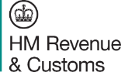
The Personal Allowance is the amount of income you can earn before paying tax. The standard Personal Allowance for 2025/26 is £12,570.

If your total taxable income is more than your Personal Allowance, You will pay tax. National insurance contributions will not be deducted from your LGPS pension payments.

Each year your employer or your pension scheme (if you have a pension in payment) will give you a P60. Your P60 shows what you have been paid, and how much tax has been deducted. It is important that you keep your P60 in a safe place.

For more information on income tax, contact HM Revenue and Customs or visit the Government’s income tax website.

Phone: 0300 200 3300 Website: www.gov.uk/income-tax

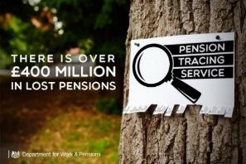
Tracing previous pension rights
There could be £30 billion in unclaimed, inactive or lost pension savings. People have saved this money for their retirement.
To plan for your retirement, you need to know how much income you will get. This includes income from workplace or personal pension plans and the State Pension.
If you have lost track of a pension, there is a Government service you can use to find contact details for:
- your own workplace or personal pension scheme
- someone else’s scheme if you have their permission.
You can access the service through the Pension Tracing Service website.
Remember to keep your pension providers up to date with any change in your home address.


Pension scams
You have worked hard to build your L G P S pension. Scammers may try to get their hands on your pension savings.
Scams are hard to spot and are often disguised with credible websites, testimonials and materials which make them look like the real thing.
The Pension Scams Action Group can help you spot the signs and protect yourself from a scam. The Group is a multi-agency taskforce of law enforcement, government and industry working together to tackle pension scams. The Pension Scams Action Group has put together a checklist to go through if you are ever approached about your pension:
Step 1 - Is the offer unexpected?
Legitimate pension providers are highly unlikely to contact you out of the blue about your pension. Be wary of free pension review offers and/or promises of high/guaranteed returns.
Step 2 – Have you checked who you’re dealing with
The Financial Conduct Authority’s (FCA) website has a Financial Services Register you can check to make sure that anyone offering you advice or services is authorised to do so.
A firm pretending to be an authorised firm is known as a ‘clone firm’ and may have a clone website that looks exactly like the real deal. Tip: double check their contact details against the register and see if they match. Always ensure a firm is FCA-authorised or you won’t be protected by the Financial Ombudsman Service or Financial Services Compensation Scheme if something goes wrong. Visit the website at register.fca.org.uk or phone 0800 111 67 68
Step 3 - Stop and think – are you being rushed or pressured?
Pressure to act quickly or you will miss out is often a warning sign. Take your time to make all the checks you need and remember, if it sounds too good to be true, it probably is.
Step 4 - Should you seek impartial advice or guidance?
MoneyHelper
Free and impartial information and guidance available online, over the phone and via webchat.
Website: www.Moneyhelper.org.uk Phone: 0800 011 3797.

Financial advisers
If you can, it’s a good idea to invest in speaking to a financial adviser. Often large amounts of money are at stake and they will be able to help you make the right decision for you. Tip: check any adviser you choose to use is regulated by the FCA.

Stop! Think Fraud
Learn more about how to spot and avoid scams. at stopthinkfraud.campaign.gov.uk.

If you suspect a scam, report it.
You can report an unauthorised firm or scam to the F C A using the online reporting form or on 0800 111 6768.
If you suspect a scam, report it to Action Fraud on 0300 123 2040 or at www.actionfraud.police.uk/.
Be ScamSmart with your pension. To find out more, visit www.fca.org.uk/scamsmart

Where to go for support


Pension Wise is a Government service from MoneyHelper that offers free, impartial guidance once you reach age 50, to help you understand your defined contribution pension options. Find out more on the MoneyHelper website or by calling
0800 011 3797.

MoneyHelper offers impartial money and pensions guidance that is backed by the UK government and free to use.

Which? is the largest independent consumer body in the UK. They provide unbiased advice and publish guides for consumers, including on pension issues.


Unbiased is a website listing regulated and independent financial advisers, mortgage brokers, solicitors and accountants. It checks that everyone is registered with the Financial Conduct Authority (FCA).

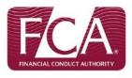
The Financial Conduct Authority (FCA) is the regulatory body for independent financial advisers. The FCA can assist you with spotting the signs of investment and pension scams.


Citizens Advice is a network of 240 independent charities throughout the United Kingdom that give free, confidential information and advice to assist people with money, legal, consumer and other problems.


Age UK provides information and advice on money and legal matters, health and wellbeing, care and support and lots more.
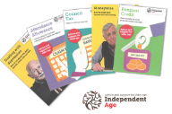
Independent Age is an older people’s charity based in the UK. They provide a variety of information such as assistance with council tax, pension credit, attendance allowance and lots more. You can view all their support on the Independent Age website or you can telephone them on 0800 319 6789.

Budget Planner
It is important to understand where you are spending your income. This will help you to work out how much income you will need in retirement. You can use this budget planner as a starting point.
Income (weekly/monthly) | Amount
Wage/Salary | £
Wage/Salary (Partner) | £
Benefits | £
Other 1 | £
Other 2 | £
Other 3 | £
Total Income | £

Outgoings (weekly/monthly) | Amount
Mortgage/rent | £
Loans, credit cards | £
Ground rent/service charge | £
Insurance | £
Council Tax | £
Gas | £
Electricity | £
Water | £
Food/housekeeping | £
Travel | £
Telephone / mobile phone | £
TV licence / TV subscriptions | £
Internet | £
Clothing | £
Prescriptions/health costs | £
Emergencies | £
Other 1 | £
Other 2 | £
Other 3 | £
Total outgoings | £
Total income | £
Total outgoings | £
Available income | £

How to find out more
You can find more information about the Local Government Pension Scheme from the L G P S member website.
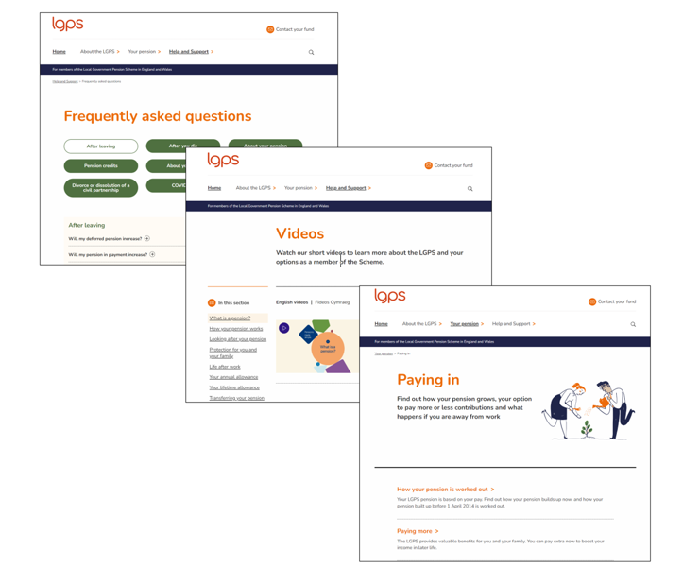
You can visit the NYPF’s website at www.nypf.org.uk

The NYPF can also be contacted:

By email: pensions@northyorks.gov.uk

By phone: 01609 536335 – lines are open between 10am and 4pm every weekday excluding Wednesdays all day

In writing: County Hall, Northallerton, North Yorkshire, DL7 8AL

Disclaimer
The purpose of this guide is to assist members with their retirement planning. It is for general use and cannot cover every personal circumstance. The guide does not cover fully the annual allowance and the tax implications for members who exceed it. This guide does not confer any contractual or statutory rights and is provided for information purposes only. In the event of any dispute over your pension benefits, the appropriate legislation will prevail. This document was correct at the date it was written. Factors and information may change; please visit the relevant websites if required.

Notes

